The nature of the gene

How do cells make proteins?

Give each student a card on which is printed a set of instructions. Each person has a different role to play in the production of an end product.

The aim of the role-play is to identify the following components to the system:
Template (DNA), Messenger (mRNA), Manufacturer (Ribosome), Helper (enzyme), Gopher (tRNA) and Building blocks (amino acids).

What is the evidence that nucleic acid (e.g. DNA) is the template?
- a template needs to be variable because proteins are variable
- experimental work has identified the nucleus (containing DNA) as being the container of a cell’s information
- experimental work has identified nucleic acids as being able to transform bacterial cells (Avery)
- DNA is capable of being accurately copied (so that daughter cells have the same information as the parent)

The structure of nucleic acids

There are two important nucleic acids: DNA and RNA
DNA is a polymer made from monomers called nucleotides.
Nucleotides are made of three sub-units.

the sugar is a 5 carbon sugar
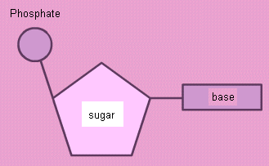(ribose in RNA and deoxyribose in DNA)

phosphate is phosphoric acid (H₃PO₄)

the base is an organic molecule, there are 5 different bases - adenine, thymine, guanine, cytosine and uracil

(DNA - ATCG, RNA - AUCG)

Nucleotides form polynucleotides by condensation reactions, forming bonds between the sugar of one and the phosphate of the next.

The key way that polynucleotide’s structure is related to their function is the way that they form long chains of variable length, the bases stick out of the side in a regular way with H atoms facing outwards, the 4 bases (in each molecule) form a 4-letter alphabet (and in the same way that letters form words and sentences, the bases can form instructions of how to build proteins).

DNA structure

Evidence for the structure of DNA comes from the following pieces of evidence:
- extracted DNA has a fibrous structure
- biochemical analysis has identifies the 3 sub-units to nucleotides
- X-ray chrystallography suggests the structure is a twisted ladder
- proportions of C and G, A and T are roughly equal suggesting that they are linked

Watson, Crick, Wilkins and Farnklin produced a hypothesis for the structure i.e. that of a double helix with hydrogen bonds holding the two sides together.

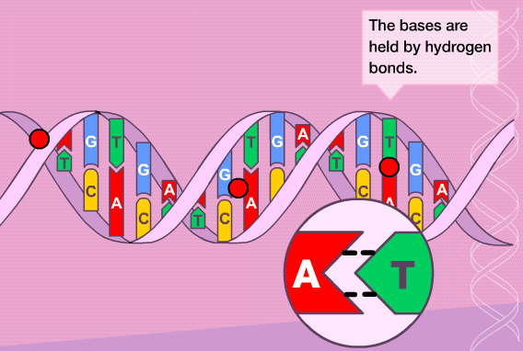

DNA structure animation.

Find and fill in online homework at http://kscience.users.btopenworld.com/as/.

Review with DNA PowerPoint slideshow.

Practice base-pairing using Lambda sequence.
DNA Replication

Accurate replication is one of the required features of a genetic system.

The base pairing provides a model for the replication e.g. before cell division.

Whole process is controlled by enzymes, the most important one being DNA polymerase.
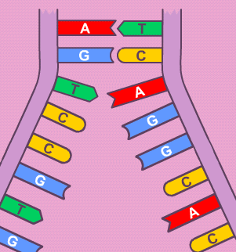
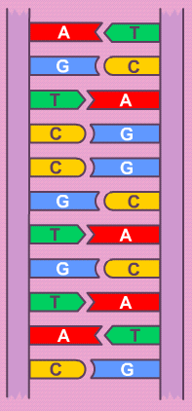The double strand unwinds and an enzyme splits the two sides.

DNA polymerase attaches to one of the strands and starts to work along in a particular direction.

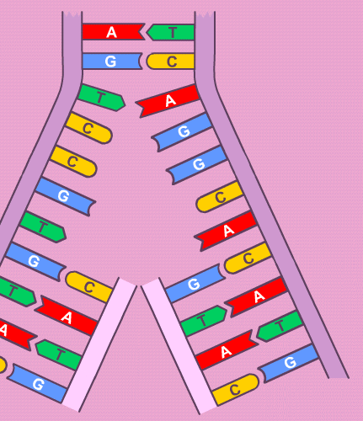Meanwhile DNA polymerase attaches to the other strand, working in the opposite direction.

The strands are used as templates, base-pairing produces exact copies.

Nucleotides in the cytoplasm are positioned by the enzyme and the condensation reactions are catalysed by it.

DNA is probably replicated in short bits and they are joined together at the end by another enzyme.

DNA polymerase then detaches.

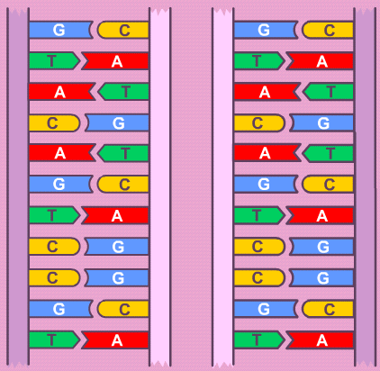
The new strands are each formed from an old strand and a new one. This is called semi-conservative replication.

AS Guru animation to review the process.

Use a 12 base sequence strand to draw the 4 stages to the process on paper.

What might the advantages to this system be?

The genetic code

How is the structure of a mug adapted to its function?

How is the structure of DNA adapted to its function?

- nucleotide sequence provides an instruction
- base pairing provides a method of reliable copying
- double stranded protects its integrity
- helix is compact
- variable length provides a variable instruction length
- base pairing provides a means to produce working copies

The code consists of letters (bases) built up into words built up into sentences (whole instructions called genes).

How many letters are there in the genetic alphabet? 4

How many different words are needed by the genetic system? 20
How many different words could you get if they were all 1,2,3,4 letters long? 4^{n} (4,16,64,256)

How long do the instructions need to be? variable, it depends on the polypeptide that is to be made.

Genes are made up of fixed-length words, each 3 bases long.
The words are called triplets.
The amino acids are represented by more than one specific triplet, this is called redundancy.
3 of the triplets represent a stop instruction.

The production of a polypeptide has the following sequence:

- The gene unwinds so that the sequence of bases is accessible.
- An RNA copy is made from one strand (sense) using base pairing.
- The RNA moves out of the nucleus through a nuclear pore.
- The RNA is attached to a ribosome.
- The triplet code is used to position amino acids so that they join together.
- When a stop instruction is reached, the polypeptide detaches.

How to make a polypeptide ICT activity.
Mutations

Point mutations are changes to single bases in genes.

There are 3 types of point mutations.
- Insertions – a base is added to the sequence between two existing bases.
- Deletions – a base is lost from the sequence.
- Substitutions – a base is replaced with a different base.

Mutations are sometimes beneficial because they generate variability, which is the basis of natural selection.

Mutations are more often deleterious because selection in a species has selected for the genome it now has and changes are therefore more likely to be less useful.

Mutations can lead to severe loss of function e.g. Thalassaemia.

Many cancers are due to mutations in genes that regulate cells.

There is a natural, background rate of mutation (average 1 in 10⁶ cell divisions) and many are repaired. The redundant nature of the genetic code will also account for some mutations having little or no effect, since a substitution may not affect the amino acid that a triplet codes for.

Mutation rate can be increased by ionising radiation (X-ray, UV, beta and gamma radiation) and some chemical substances. They are termed mutagenic.

Mutations to body cells (somatic) cannot be inherited. However, mutations to gametes can.

Genetic code worksheet.

How do genes work?

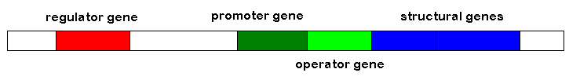
A set of genes are responsible for the production of an enzyme.
- regulator, produces a protein (by transcription and translation) that inhibits the production of the enzyme by binding to the operator gene and preventing expression of the structural gene(s).
- promoter, the binding site for RNA polymerase, it also ensures that transcription is on the sense strand.
- operator, normally gets in the way of expression.
- structural, code for the polypeptides needed for the enzyme and any associated other proteins.

This model could explain how genes are switched on or off.
A gene may be switched on if a substance binds with the inhibitor made from the regulator gene, stopping it from binding with the operator.

A gene may be switched off if a substance binds with the inhibitor, enhancing the way that it binds with the operator.

Metabolic pathways can be regulated by end-products or intermediate substances affecting the genes responsible for the production of enzymes in this way.

Metabolic pathways may be controlled by a series of enzymes and therefore by a series of genes.
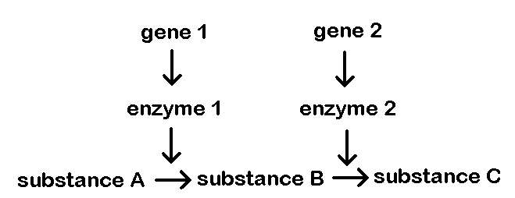

Fungal metabolic pathay worksheet.
Salmonella typhimurium worksheet.

Cancers can be explained by mutations in regulator genes causing them to produce defective proteins that no-longer control a cell’s cell cycle. The cell may then divide when it should be prevented and lead to a generation of cells with the same defective gene. This could lead to a tumour and possibly to secondary tumours. (See page 102 – oncogenes, activity 1).

Case Study – Cystic Fibrosis

Normal CTFR gene codes for a channel protein in the membrane of epithelial cells. It allows the transport of chloride ions out of cells and this helps to create a water potential gradient so that water follows it and mucus produced by the goblet cells in the epithelium is runny.

In a mutation one of the 1480 amino acids is different, which affects the proteins tertiary structure and so it cannot transport chloride ions.

If a person has one normal gene, they produce enough CTFR to make normal mucus, but two copies of the gene means that the person suffers from cystic fibrosis.
The cell cycle

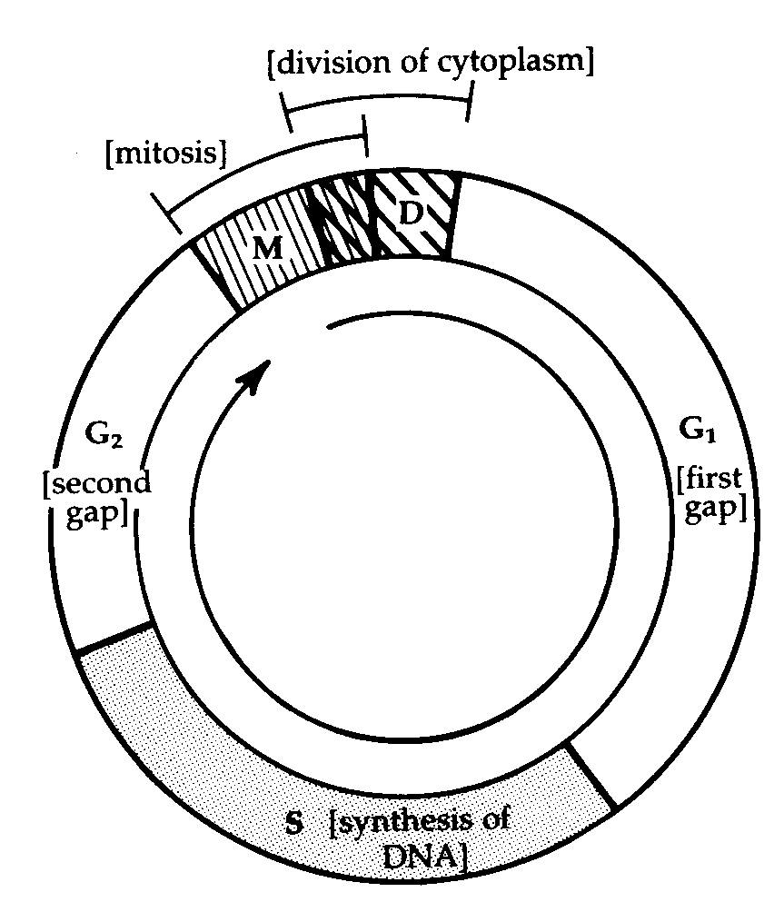
If growth factors are still influencing the cell and the control genes (proto-oncogenes) are switched on, the cell will continue in a cycle of growth and division. If the growth factors stop, the cell may then be influenced by other chemical and start to differentiate.

In G1, the cell grows, organelles are synthesised and proteins are synthesised.
The S stage is when DNA is replicated.
In G2, the cell continues to grow and ATP is produced.
The cell then enters the M (mitosis) stage.
The final stage is the division or cytokinesis stage when the cytoplasm is divided to make two cells by the development of membrane. Contractile proteins pinch the cell. In plant cells, a plate of cellulose forms from the middle (celled the cell plate).

How does the cell cycle ensure that each daughter cell has the same genetic information as the original?

The cell cycle provides cells for growth, eventual development of new tissues, repair and asexual reproduction.

Examples of asexual reproduction are in protoctists such as amoeba, fungi e.g. yeasts and the production of spores and the development of growing points (meristems) in plants e.g. potatoes.

Use pages 143 to 147 to describe the artificial methods used to produce crop plants and animal and plant clones.

