Year 8 Science Fieldwork Name _____________ Teacher ________

This booklet contains activities for you to try on your visit to Leighton Moss and Arnside Knott.

Have you been to these places before?

Leighton Moss Arnside Knott

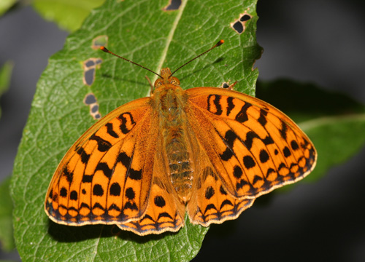
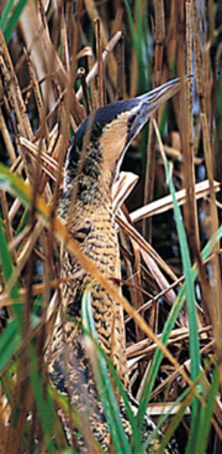
Your aims for the day are to learn something about these two places for nature and to discover why they are so important.

In addition to the activities inside - we have a challenge for you.

Slug Survey!

Slugs might be the sort of animal that makes you go urghh but we want to get an idea of how many are on each nature reserve.

Leighton Moss has an area specially designed to attract them.
You will find out how well managing the environment for wildlife works!

Every time you see a slug, add an extra to the tally below. Make sure that it goes in the right box though!

Leighton Moss | Arnside Knott
Total | Total


Leighton Moss

Leighton Moss is an RSPB nature reserve.

What does RSPB stand for?

What is a nature reserve?

Leighton Moss is a wetland habitat. This means that most of the plants and animals that live there like to live in wet places. Reeds (tall grass) and willow trees grow at Leighton Moss. Where lots of reeds grow in the same place it is called a reed bed. A reed bed is a rare habitat.

Why is Leighton Moss a special place?

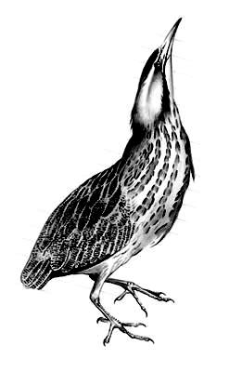
You will do three activities during your stay at Leighton Moss.
The activities will give you lots of information about wetland habitats and the creatures that live there.

Adaptations

Bitterns are strange-looking birds but they are wonderfully adapted to their reedbed habitat.

At least 5 special features are shown in the picture. How many can you spot and label?
Think of a reason for some of the features.
The reedbed habitat
How many different birds make their home in reedbeds?
Write down the names of some of them.

The open water habitat

How many different birds make their home on the lake?
Write down the names of some of them.

Feeding Methods

As you learn about the birds that live at Leighton Moss, note down the special ways that they feed.

Bird | How it feeds

Pond Dipping
Place a tick beside the picture of any creatures you find in the pond.

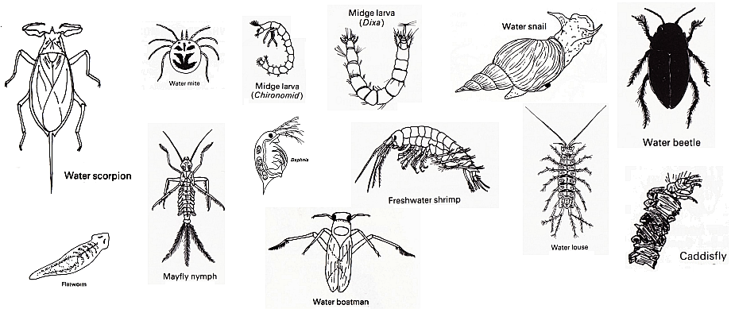

Write down the names of any extra creatures you saw in the pond.

Why are the creatures in the water important to the wetland birds that live at Leighton Moss?

Describe the special features of three of the creatures you have found.

Arnside Knott


Minibeast Study

How many different minibeasts live in this wood?

You will use some sampling methods to find out the answer. You will investigate three areas and compare the number of minibeasts that you find in each place.
L | - In Leaf litter
D | - Under Dead wood
T | - On Trees
Use this key to show where you found the minibeasts. Write the letters beside each type that you find.

How many different creatures did you find?

Which habitat seems to have the greatest number of creatures living in it?

What do all these creatures depend on for food?

Write a food chain using some of the animals you found.

Arnside Knott

Light Investigation

Why is light so important to living things?

You will find out how much light is getting to the ground in different parts of the wood and see if this makes a difference to the plants that grow there.

Quadrat | Type of woodland | Light measurement | The area of ground covered by plants
1
2
3
4
5
6
7
8
9
10

Does the amount of light getting to the ground make a difference to the amount of plants that grow there?

Why do you get different amounts of light in different parts of the wood?

Why isn’t this a very fair test?

Why does light affect plants?

If the National Trust wanted more woodland plants - which type of woodland should they try to have?

Arnside Knott

Grassland

The field in front of you is one of the most important sites on the nature reserve. You will find out what makes it more special than the school field or a field on a local farm.

Task 1

Quadrat | Number of different plants | Quadrat | Number of different plants
1 |  | 6
2 |  | 7
3 |  | 8
4 |  | 9
5 |  | 10

Use your results to fill in this table to compare different grasslands.

Type of grassland | Mean number of different plants
School field | 4
Farm field | 2
Nature reserve

Why is this a nature reserve?

Task 2

Write the names of some of the grassland plants in the boxes below.

Which nature reserve?
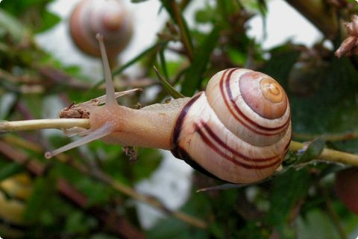 | 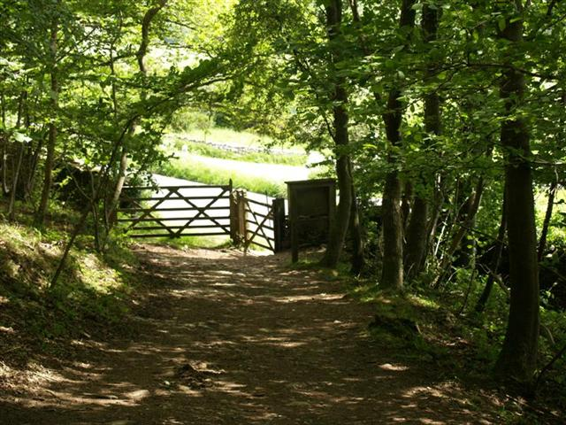 | 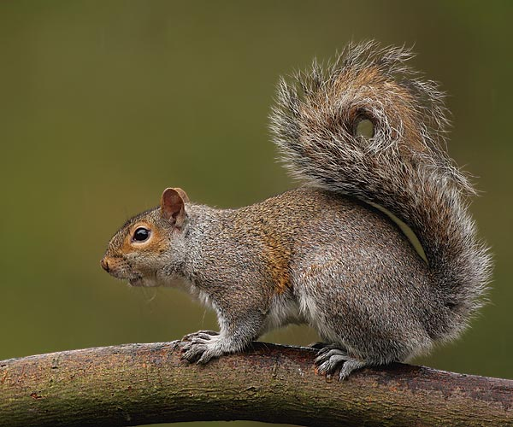
______________ | ______________ | ______________
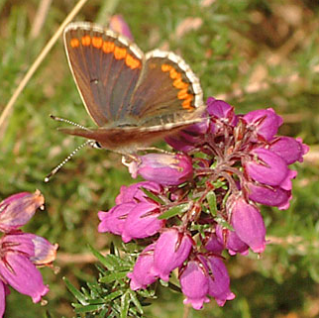 | 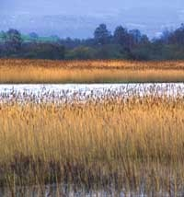 | 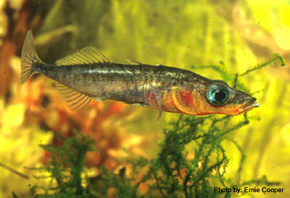
______________ | ______________ | ______________
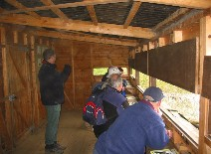 | 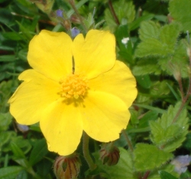 | 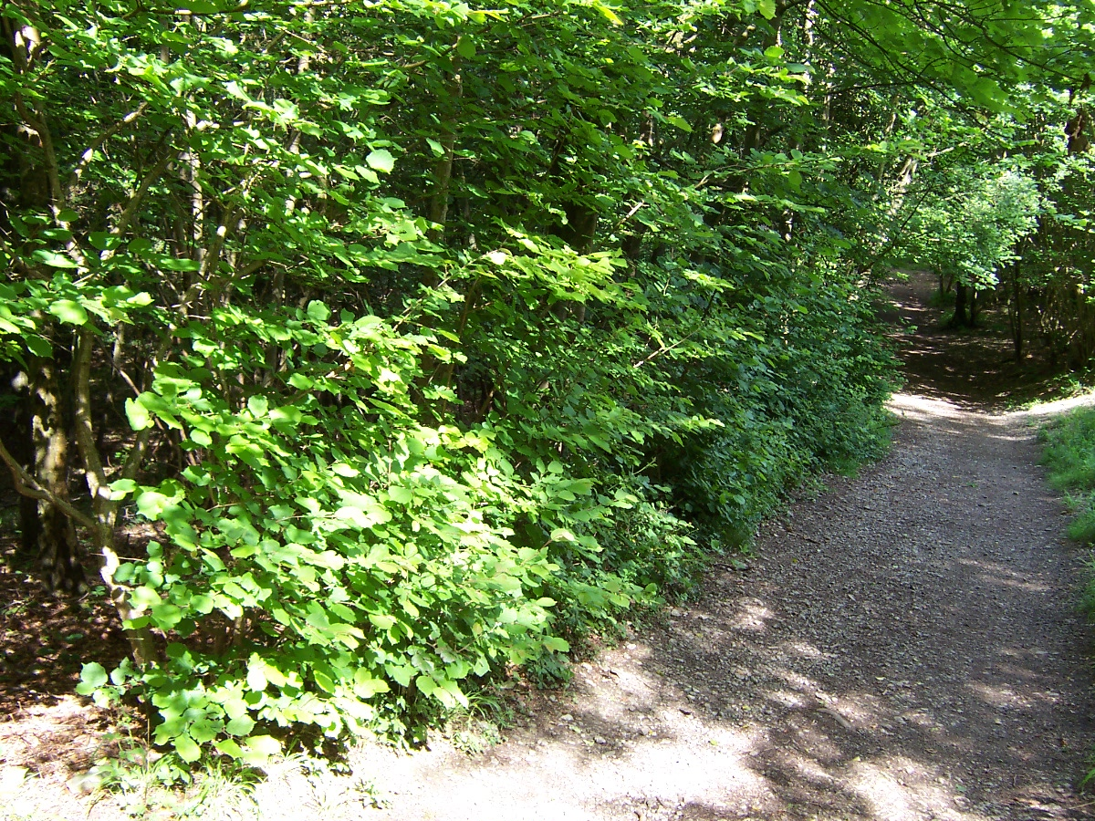
______________ | ______________ | ______________
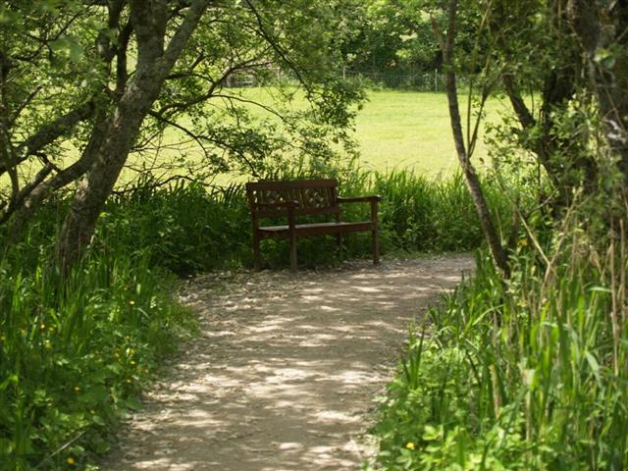 | 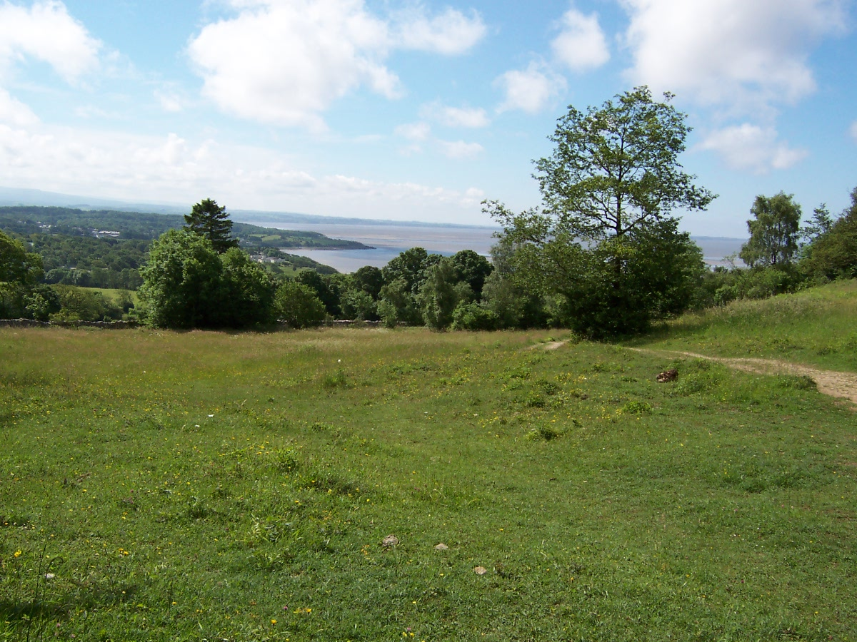 | 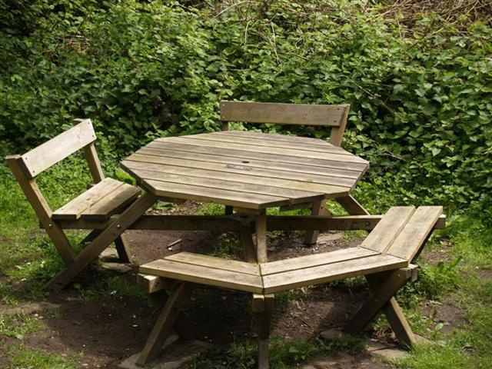
______________ | ______________ | ______________
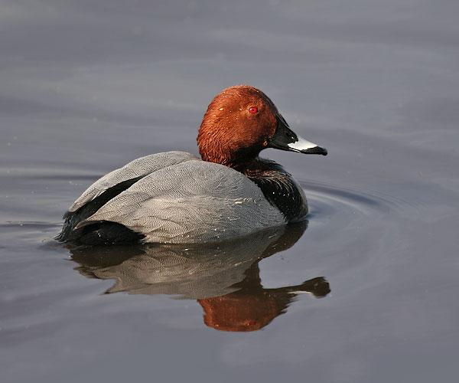 | 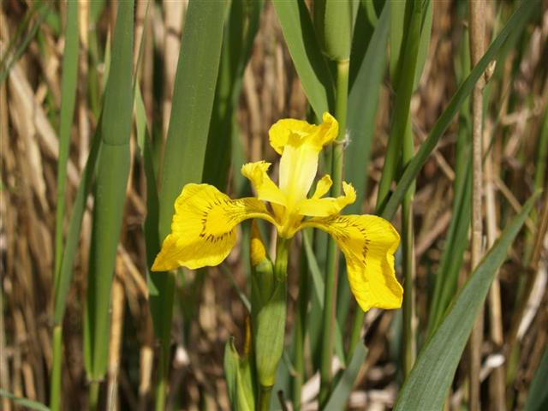 | 
    

